Instruction for setting up website and unity application
Required software:
-VS Code
-XAMPP

First step in setting up whole project is to install newest version of Node.js. It can be installed from official website:
https://nodejs.org/en/download
Website files can be placed in one folder with subfolders. File structure:
mainFolder
-subfolder “client,,
-subfolder “server,,
Unity application can be placed in other folder not necessary the same folder as website files, but keeping them in same folder will make it easier to manage them.
Xampp install fiels can be downloaded from official website.
https://www.apachefriends.org/pl/download.html

After installing all required software and dependencies we can start setup.

Setting up database.
Database is set and manage with use of Xampp software. Steps to seet it up: First step is to open XAMPP software. Then this window should pop up
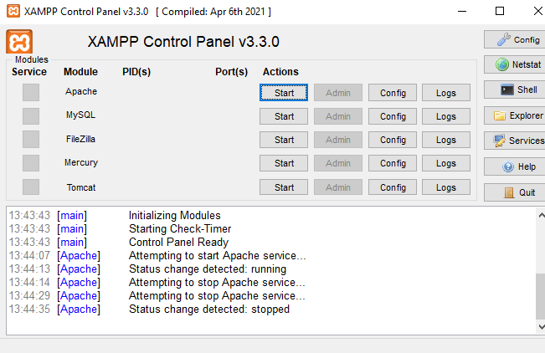
In this window we need to click start button for Apache and Mysql. It should look like this
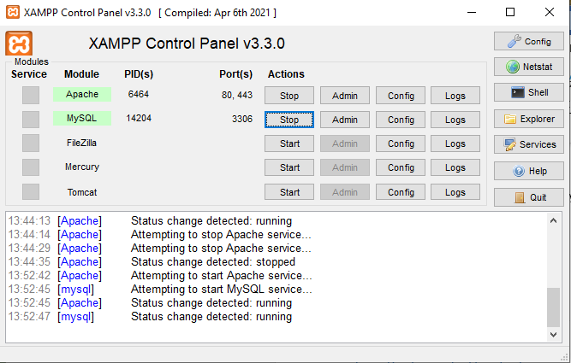
After that we can click button Admin in Apache row.
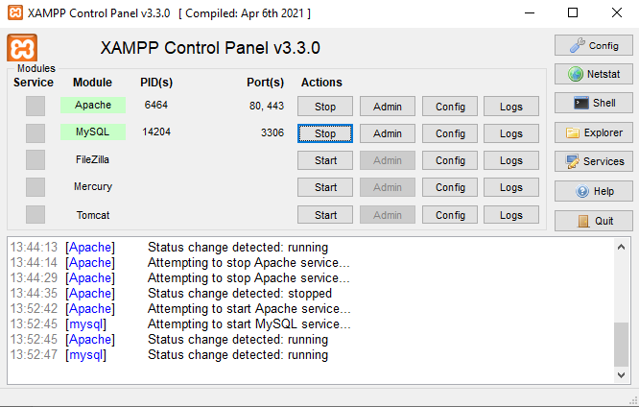
New browser tab should open after than. In my case Chrome is being opened. It will look like this 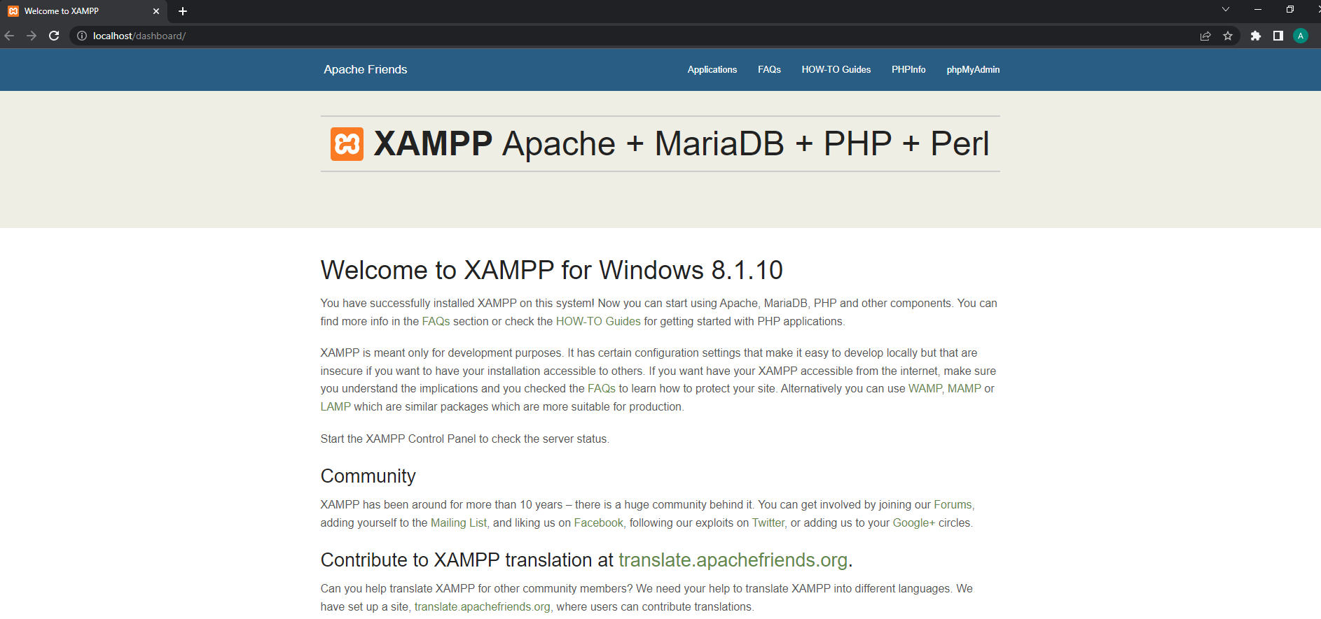
In here we need to click phpMyAdmin on navbar.
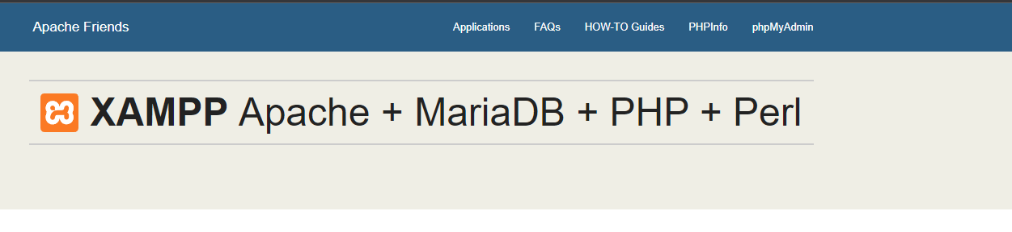
After clicking it side for managing databases should open.
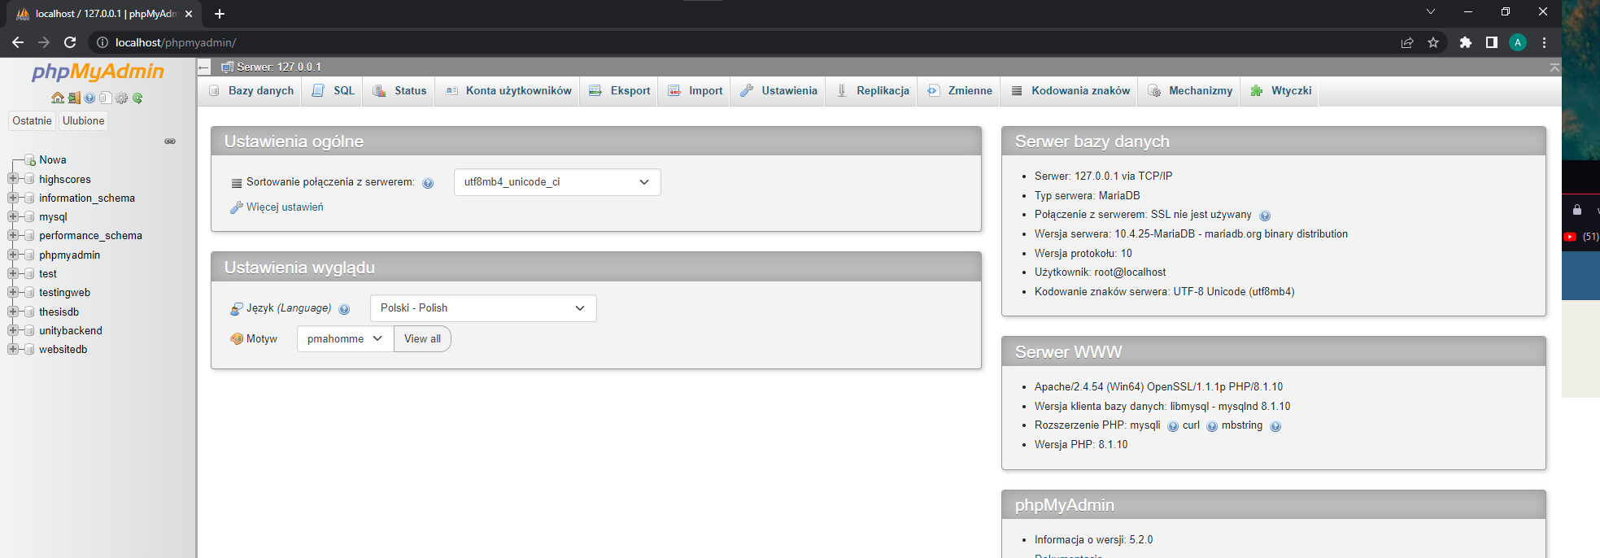
After that we need to create empty database for import. We click ‘’Nowa,, in database sidemenu to create new database
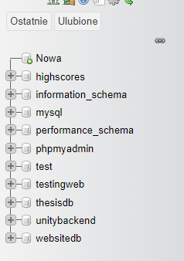
We input database name in the field and create database. Name of database need to be the same as the one in project “websitedb”.
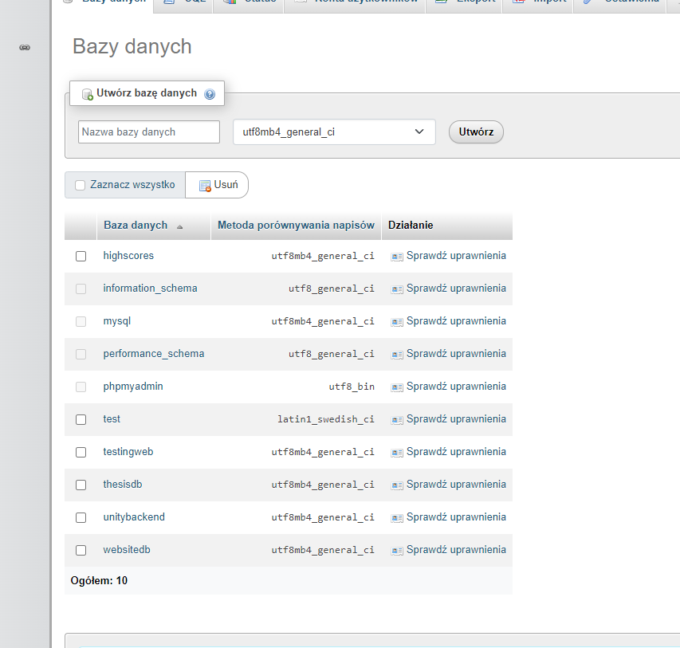
From here we need to go to import tab
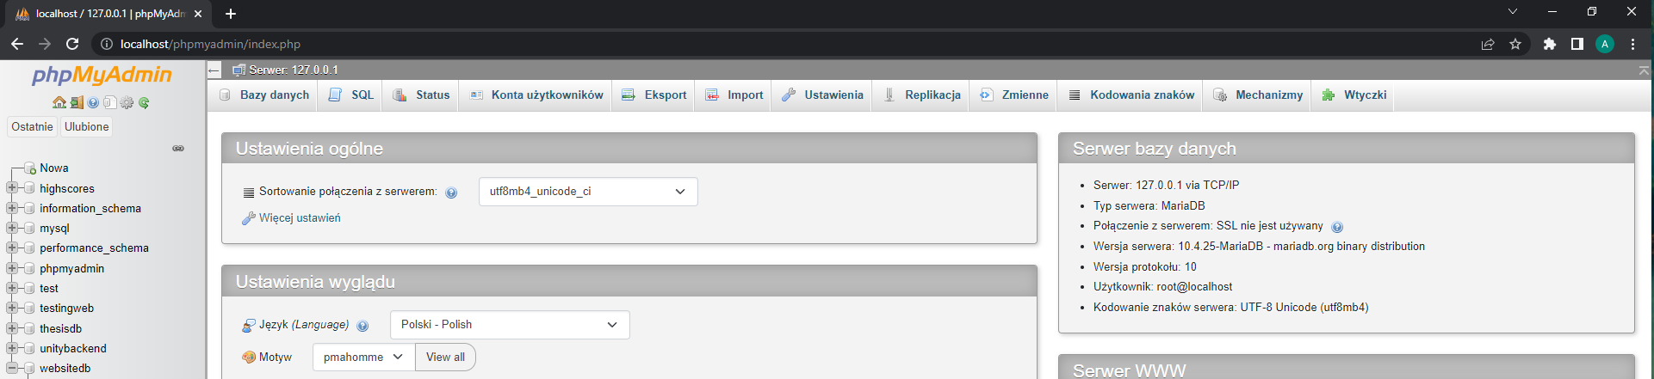
In here we can import database with use of file with .sql extension.
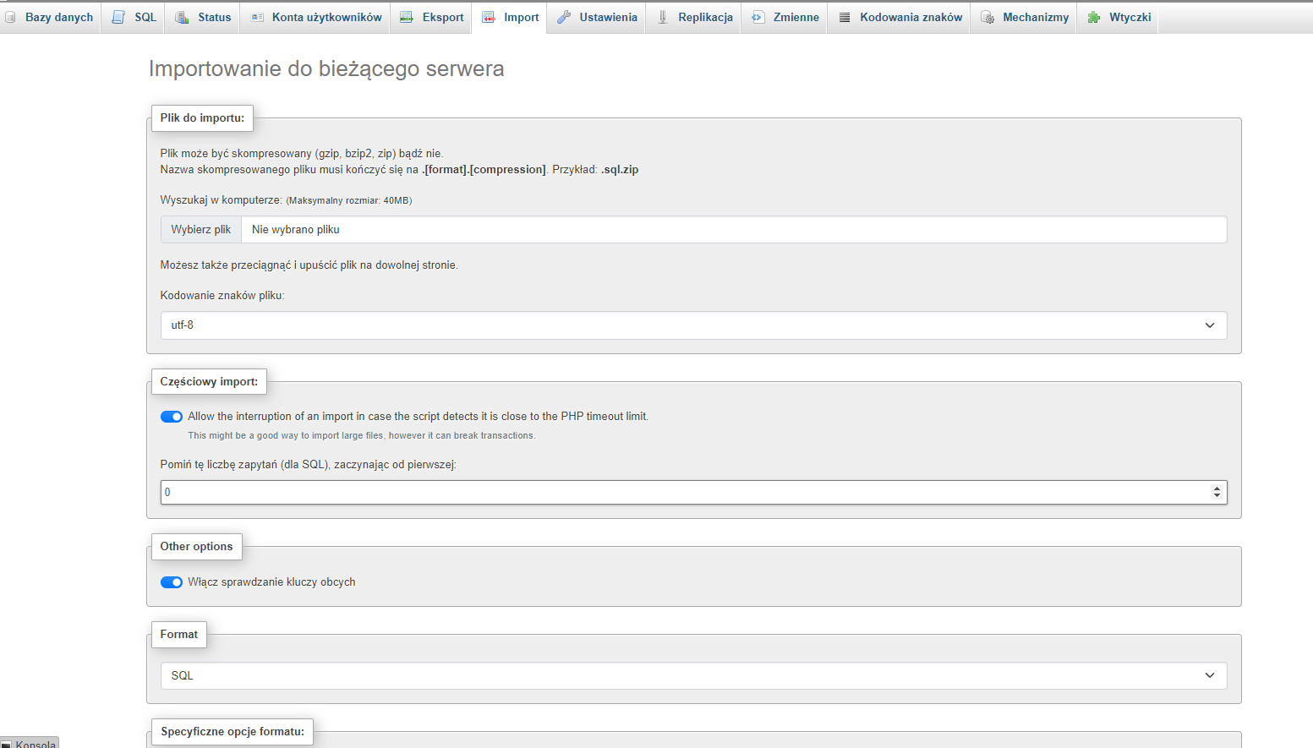
We select file with our database data.
Scroll down and click import.
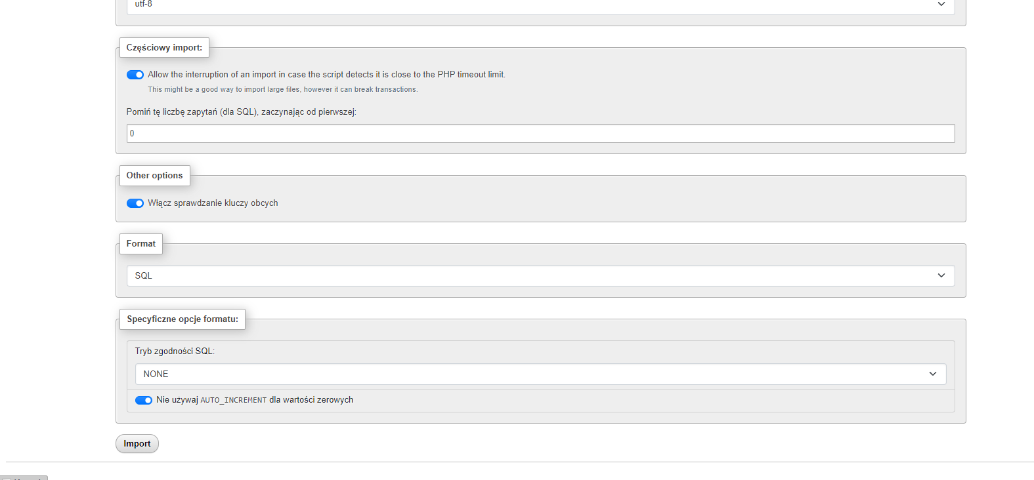
After that new database should be imported and it should be visible on sidebar.

Setting up website
To set up server for the website, first we need to open folder with website files win VS Code. We can open main folder or open separately server and client folder.
If we opened main folder in VS Code.
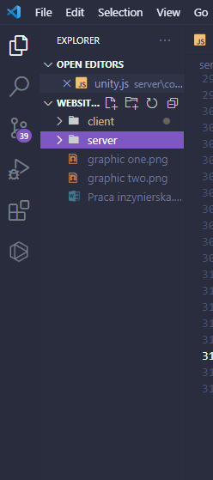
Now we would need to move to specific folder in VS Code with use of terminal. We can open second terminal with use of “+” button on the side
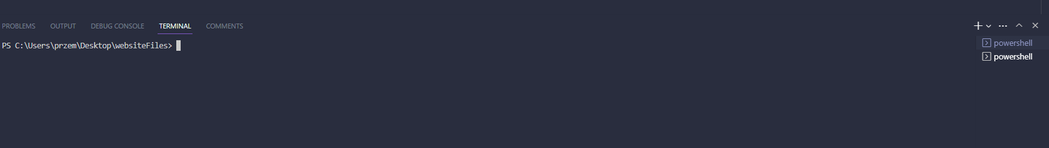
In first terminal we need to move to server folder with command:
cd server
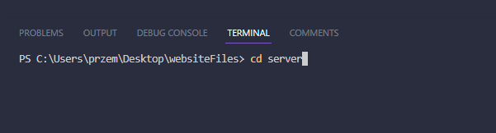
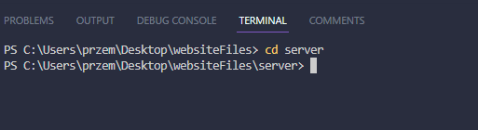
With this we should move to server folder. In here we should first install all dependencies needed to run server if they are not in the files:
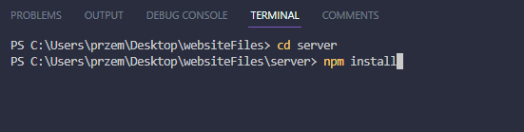
After that if we installed all dependencies we can run server with command:
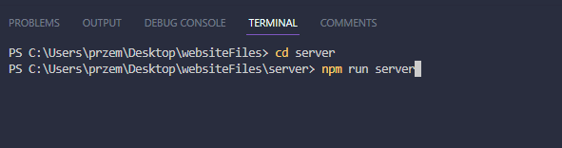
After running this command server should start
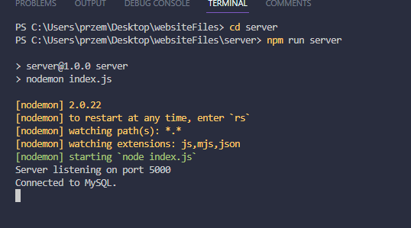
Setting up client
To run client we need to in second terminal move to client folder with command:
cd client
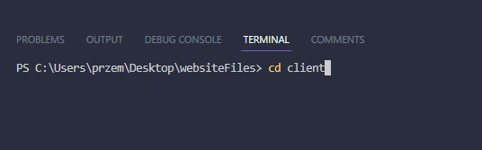
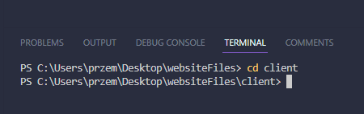
After than similarity if we need to install dependencies we can do it with command
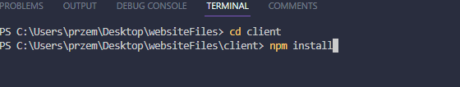
After that we can start client
After running this command website should open in browser.
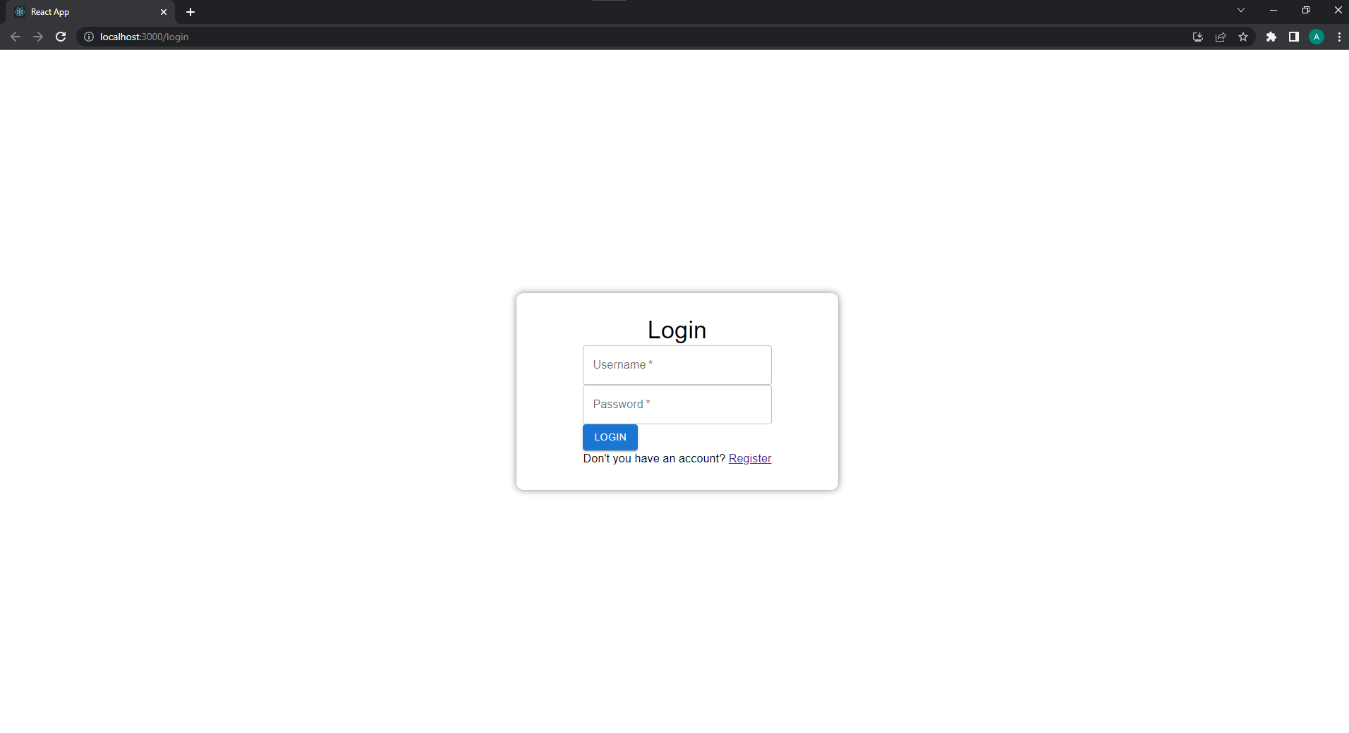

Unity setup
Unity application will be in form of build which will allow to run unity application without any setup. Unity application is started by the file: ThesisBackendTesting
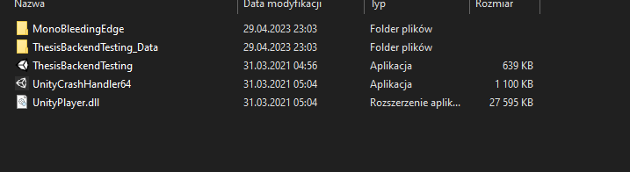
After executing this file unity application should open.

